# INTRODUCTION TO PROJECT

The web based “Online Medical Store” project is an attempt to stimulate the basic concepts of airline reservation system. The system enables the customer to do the things such as search for airline flights for two travel cities on a specified date, choose a flight based on the details and reservation of flight

In Present scenario computer is an essential part for human life. It provides better facilities for storage and retrieval of information related to different areas of application.

"Medical Store Management System" is the software that will help to any medical store in its better stock maintenance and various sales purchase reports

online medical shop project in java. This project is a web application which is developed in Java. Work on the Sales Reporting And Management System-Pharma project to enhance the growth of pharma employees/ companies. this project is to develop an online web portal that can handle product information, can booking from distributors very fast from all over the world and online payment for orders and customer support for distributors.

This type of application will atomize the procedure of drug supply through the Pharmaceuticals Company and improve business standards and customer relationships. This application is use distributors can view detailed information of transactions and get drugs information and see future orders from his account. Customers can easily visit this site and register themself, by filling a registration form. Once a customer is registered he/she can login using their email and password and can buy products available. Users can also view doctors with their descriptions, clinics, and timings.

**2.REQUIREMENTS**

**2.1 FUNCTIONAL REQUIREMENTS**

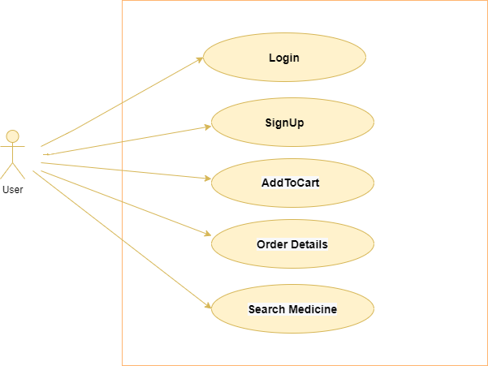

**2.1 User Account**

The Customer, who will henceforth be called the ‘user’, will be presented all the medicines and category wise medicine , as the first step in the interaction between them. A user can choose any of these medicines that he want to purchase. To see all these medicine first he have to register to account with valid email and password then and then he will able to see all essential medicines he/she want to purchase.

For buying any of the medicines user has to do registration part to create account for user and then he has to do login with register email and password.

Then after login user can see all medicines and purchase them by adding in to the cart here only available medicines will be displayed to the user hence there will be no conflict

Between medicine availability and users need. The price of the medicine, description and name will be displayed below the medicine image and user will see all the details about medicine like name, price, manufacturing Date, Expiry Date etc.

Following are the steps for user Account :

1)User have to register with correct information

2)User have to login with valid email and password further authentication will be done on the basis of that and after that logout will be displayed on left side.

3)User can see all the medicines and details.

**2.2 Registration and creation of user profile**

The system shall require a user to register, in order to create user account and carry out login process for further transactions to purchase medicines. It will ask the user for the following information at the least – a user id, a password, first name, last name, address line, postal code, state, country, phone number, email address here by default role will already be selected as user.

**2.3 Registration and creation of user profile**

After 2.2 step that is after creating user account The system shall require a user to login, with valid email id and password in order to carry out any transactions with it or to purchase or buy medicines whichever he required. It will ask the user for the following information at the least – valid Email Id and Password for login in to his/her account.

* 1. **Add To Cart**

The add-to-cart button is a feature of ecommerce stores that allows customers to choose

items to purchase without actually completing the payment. For online stores, it lives on individual product pages, functioning as the digital equivalent of a shopping cart in a brick and mortar store.

As opposed to a buy button or a buy now button, the add-to-cart button allows customers to save items to their cart so they can continue shopping, then complete the checkout process later on in the process, resulting in a more seamless customer experience. It also allows shoppers to purchase multiple items at one time.

After having taken the user through the step 2.2 that is registration (creating user profile and login), The system will display all the medicines and categories so user can easily see medicines category wise sorted. Then

1. User can see details of medicine if he click on any image of medicine and he can click on add to cart button.
2. But first system checks before add to cart user has logged in/ register or not if yes then he will surely buy and add to cart medicines.
3. After clicking on add to cart button the medicine details like price, quantity he want to purchase , manufacturing date , expiry date will be seen on cart details here user can buy different medicines and can increase or decrease quantity accordingly and then he have to click on place order.
4. After this order details will be seen.

**2.5 View Order Details**

The system shall allow a user to view all information about his orders of different medicines. But user can see his order details after login. Order details will be medicine name, total price, quantity , when user has placed order etc in tabular format.

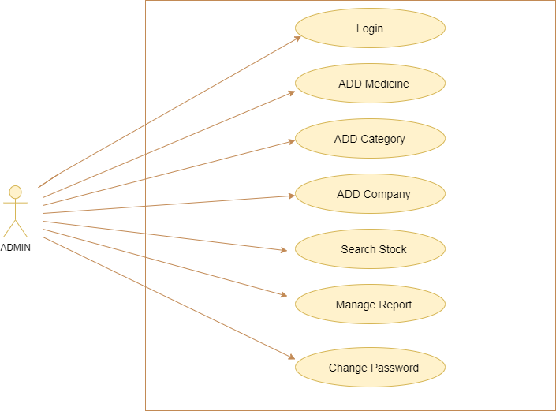

**Admin Account**

Admin should be able to login ,add medicines information , Company information , add stock , increase or decrease stocks accordingly. Admin can also see user details except password which is belong to that particular users and can delete user account in case of any suspicious user account.

* 1. **NON FUNCTIONAL REQUIREMENTS**

**2.2.1 Interface**

Go to Appendix B for user interfaces.

**2.2.2 Performance**

* **Number of Concurrent Users:**

System shall be able to handle Transactions smoothly.

* **Order Medicines:**

The system is susceptible to any temporary server failure since it uses the strong

feature of Spring Boot and Hibernate.

**2.2.3 Constraint**

System shall be able to handle Transactions smoothly.

**2.2.4 Other Requirements:**

* **Hardware Interfaces**

The Project/Application is expected to function on Intel CORE i5 8th Gen Processor equivalent or above, 8 GB RAM, 1 TB HDD.

* **Software Interfaces**

The Project/Application shall work on MS Windows operating systems family (MS Windows 98, MS Windows NT Workstation, MS Windows 2000, MS Windows XP). It configures to work with my sql database. This System works on Spring boot and React.

**3. DESIGN**

**3.1 Database Design**

The following table structures depict the database design.

# Table1: User_Information

|  |  |  |  |  |
| --- | --- | --- | --- | --- |
| **Key Type/ Constraint** | **Column Name** | **Data Type** | **Length** | **Allow Null (1=Yes;0=No)** |
| 3 | Id | int | 4 | 0 |
| 0 | Email | varchar | 255 | 0 |
| 0 | FirstName | varchar | 255 | 1 |
| 0 | LastName | varchar | 255 | 1 |
| 0 | Password | varchar | 255 | 0 |
| 0 | Phone | varchar | 255 | 0 |
| 0 | Role | varchar | 255 | 0 |

# Table2: Medicine Information

|  |  |  |  |  |
| --- | --- | --- | --- | --- |
| **Key Type/ Constraint** | **Column Name** | **Data Type** | **Length** | **Allow Null (1=Yes;0=No)** |
| 3 | MedicineId | int | 10 | 0 |
| 0 | MedicineName | varchar | 255 | 1 |
| 0 | MedicineDesc | varchar | 255 | 1 |
| 0 | price | double | - | 0 |
| 0 | ExpDate | date | - | 0 |
| 0 | MfgDate | date | - | 0 |
| 0 | Quantity | int | - | 1 |

# Table3: Company Information

|  |  |  |  |  |
| --- | --- | --- | --- | --- |
| **Key Type/ Constraint** | **Column Name** | **Data Type** | **Length** | **Allow Null (1=Yes;0=No)** |
| 3 | CompanyId | int | 10 | 0 |
| 0 | CompanyName | varchar | 255 | 1 |
| 0 | CompanyDesc | varchar | 255 | 1 |
| 0 | Contact | varchar | 255 | 0 |
| 0 | Location | varchar | 255 | 1 |

# Table4: Category Information

|  |  |  |  |  |
| --- | --- | --- | --- | --- |
| **Key Type/ Constraint** | **Column Name** | **Data Type** | **Length** | **Allow Null (1=Yes;0=No)** |
| 3 | CategoryId | int | 10 | 0 |
| 0 | CategoryName | varchar | 255 | 1 |
| 0 | CategoryDesc | varchar | 255 | 1 |

# Table5: Address Information

|  |  |  |  |  |
| --- | --- | --- | --- | --- |
| **Key Type/ Constraint** | **Column Name** | **Data Type** | **Length** | **Allow Null (1=Yes;0=No)** |
| 3 | AddressId | int | 10 | 0 |
| 0 | AddressLine | varchar | 255 | 1 |
| 0 | City | varchar | 255 | 0 |
| 0 | Country | varchar | 255 | 0 |
| 0 | Postal Code | varchar | 255 | 0 |
| 0 | State | varchar | 255 | 0 |

# Table6: Add Cart Information

|  |  |  |  |  |
| --- | --- | --- | --- | --- |
| **Key Type/ Constraint** | **Column Name** | **Data Type** | **Length** | **Allow Null (1=Yes;0=No)** |
| 3 | CartId | int | 10 | 0 |
| 0 | CreateDate | datetime | 6 | 0 |
| 0 | Quantity | int | - | 1 |
| 0 | UserId | int | - | 0 |

# Table7: Order Details

|  |  |  |  |  |
| --- | --- | --- | --- | --- |
| **Key Type/ Constraint** | **Column Name** | **Data Type** | **Length** | **Allow Null (1=Yes;0=No)** |
| 3 | OrderId | int | 10 | 0 |
| 0 | Amount | double | - | 0 |
| 0 | Quantity | int | - | 0 |

**E-R Diagram, Dataflow diagram and Class Diagram:**

Go to Appendix A

**4. CODING STANDARDS IMPLEMENTED**

### Naming and Capitalization

Below summarizes the naming recommendations for identifiers in Pascal casing is used mainly (i.e. capitalize first letter of each word) with camel casing (capitalize each word except for the first one) being used in certain circumstances.

|  |  |  |  |
| --- | --- | --- | --- |
| **Identifier** | **Case** | **Examples** | **Additional Notes** |
| Class | Pascal | Person, BankVault, SMSMessage, Dept | Class names should be based on "objects" or "real things" and should generally be **nouns**. No ‘_’ signs allowed. Do not use type prefixes like ‘C’ for class. |
| Method | Camel | getDetails, updateStore | Methods should use **verbs** or verb phrases. |
| Parameter | Camel | personName, bankCode | Use descriptive parameter names. Parameter names should be descriptive enough that the name of the parameter and its type can be used to determine its meaning in most scenarios. |
| Interface | Pascal with "I" prefix | Disposable | Do not use the ‘_’ sign |
| Property | Pascal | ForeColor, BackColor | Use a noun or noun phrase to name properties. |
| Associated private member variable | _camelCase | _foreColor, _backColor | Use underscore camel casing for the private member variables |
| Exception Class | Pascal with "Exception" suffix | WebException, |  |

### Comments

* Comment each type, each non-public type member, and each region declaration.
* Use end-line comments only on variable declaration lines. End-line comments are comments that follow code on a single line.
* Separate comments from comment delimiters (apostrophe) or // with one space.
* Begin the comment text with an uppercase letter.
* End the comment with a period.
* Explain the code; do not repeat it.

**5. TEST REPORT**

**Another group called Linux did the testing and the report of the testing is given hereunder.**

**GENERAL TESTING:**

|  |  |  |  |  |
| --- | --- | --- | --- | --- |
| **SR**  **-NO** | **TEST CASE** | **EXPECTED RESULT** | **ACTUAL RESULT** | **ERROR MESSAGE** |
| 1 | Signup Page | Pop-up will come | ok | Enter all Information |
| 2 | Login Page | Redirected to Next page | ok | Enter valid email and password |
| 3 | OTP Verification | Send OTP to respected email | ok | OTP not sent |
| 4 | Change Password | Only users password will be Changed | ok | Enter correct password |
| 5 | Add to cart | Medicines will be added to cart | ok | Nothing |
| 6 | Order Details | Order details will be displayed. | ok | Nothing |
| 7 | Logout | Logout user account | ok | Nothing |

**6. PROJECT MANAGEMENT RELATED STATISTICS**

|  |  |  |  |
| --- | --- | --- | --- |
| **DATE** | **WORK PERFORMED** | ****SLC Phase**** | **Additional Notes** |
| Aug 24,2021 | Project Allotment and User Requirements Gathering | Feasibility Study | Our team met the client Mr. Nitin kudale (CEO, SIIT Pune) to know his requirements. |
| Aug 25,2021 | Initial SRS Document Validation  And Team Structure Decided | Requirement Analysis  (Elicitation) | The initial SRS was presented to the client to understand his requirements better |
| Aug 28,2021 | Designing the use-cases, Class Diagram, Collaboration Diagram, E-R Diagram and User Interfaces | Requirement Analysis &  Design Phase | Database Design completed |
| Sep 1,2021 | Business Logic Component design Started | Design Phase | ---------------------- |
| Sep 2,2021 | Coding Phase Started | Coding Phase | 70% of Class Library implemented. |
| Sep 3,2021 | Implementation of Web Application and Window Application Started | Coding Phase | Class Library Development going on. |
| Sep 5,2021 | Off | Off | Off |
| Sep 9,2021 | Implementation of Web Application and Window Application Continued | Coding Phase and Unit Testing | Class Library Modified as per the need. |
| Sep 10,2021 | Implementation of Web Application and Window Application Continued | Coding Phase and Unit Testing | -- |

|  |  |  |  |
| --- | --- | --- | --- |
| Sep 12,2021 | After Ensuring Proper Functioning the Required Validations were Implemented | Coding Phase and Unit Testing | Module Integration was done by the Project Manager |
| Sep 18,2021 | The Project was Tested by the respective Team Leaders and the Project Manager | Testing Phase (Module Testing) | -- |
| Sep 19,2021 | The Project was Submitted to Other Project Leader of Other Project Group For Testing | Testing Phase (Acceptance Testing) | The Project of Other Team was Taken up by the Team for Testing |
| Sep 20,2021 | The Errors Found were Removed | Debugging | The Project was complete for submission |
| Sep 24,2021 | Final Submission of Project |  |  |

Appendix A

**Entity Relationship Diagram**

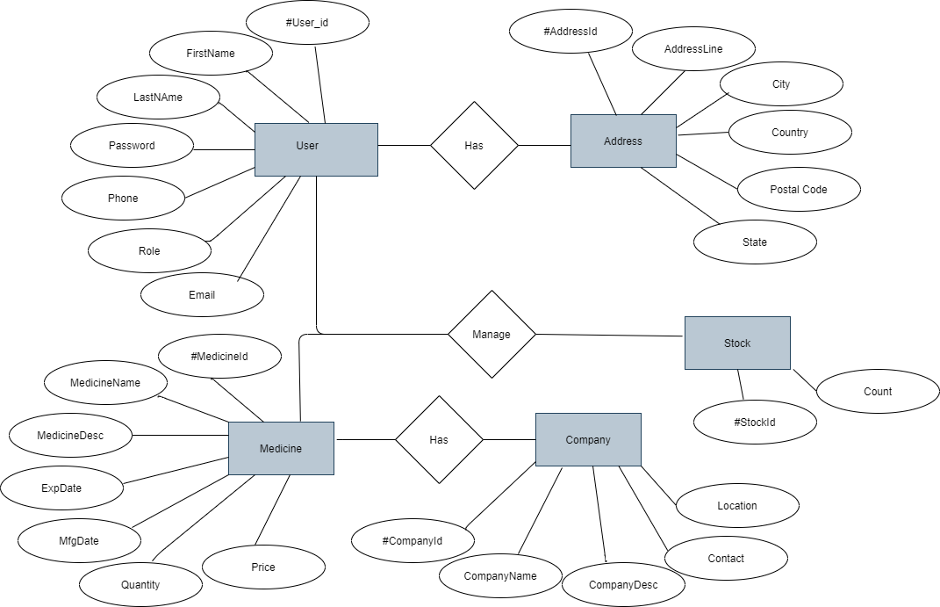

**Class Diagram**

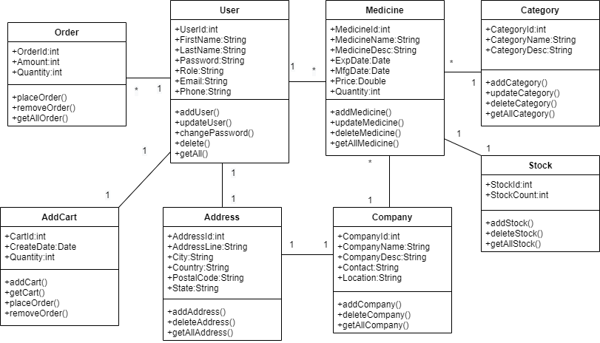

**Data Flow Diagram**

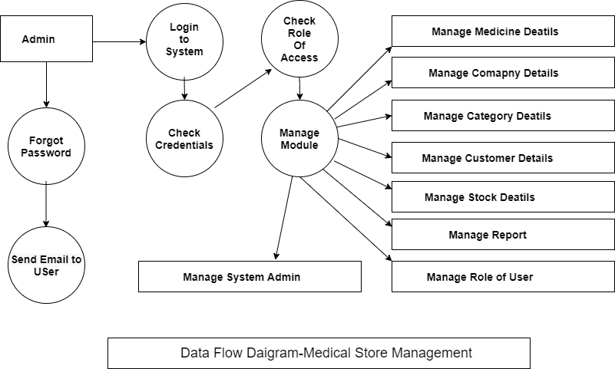

Appendix B

**Home Page**

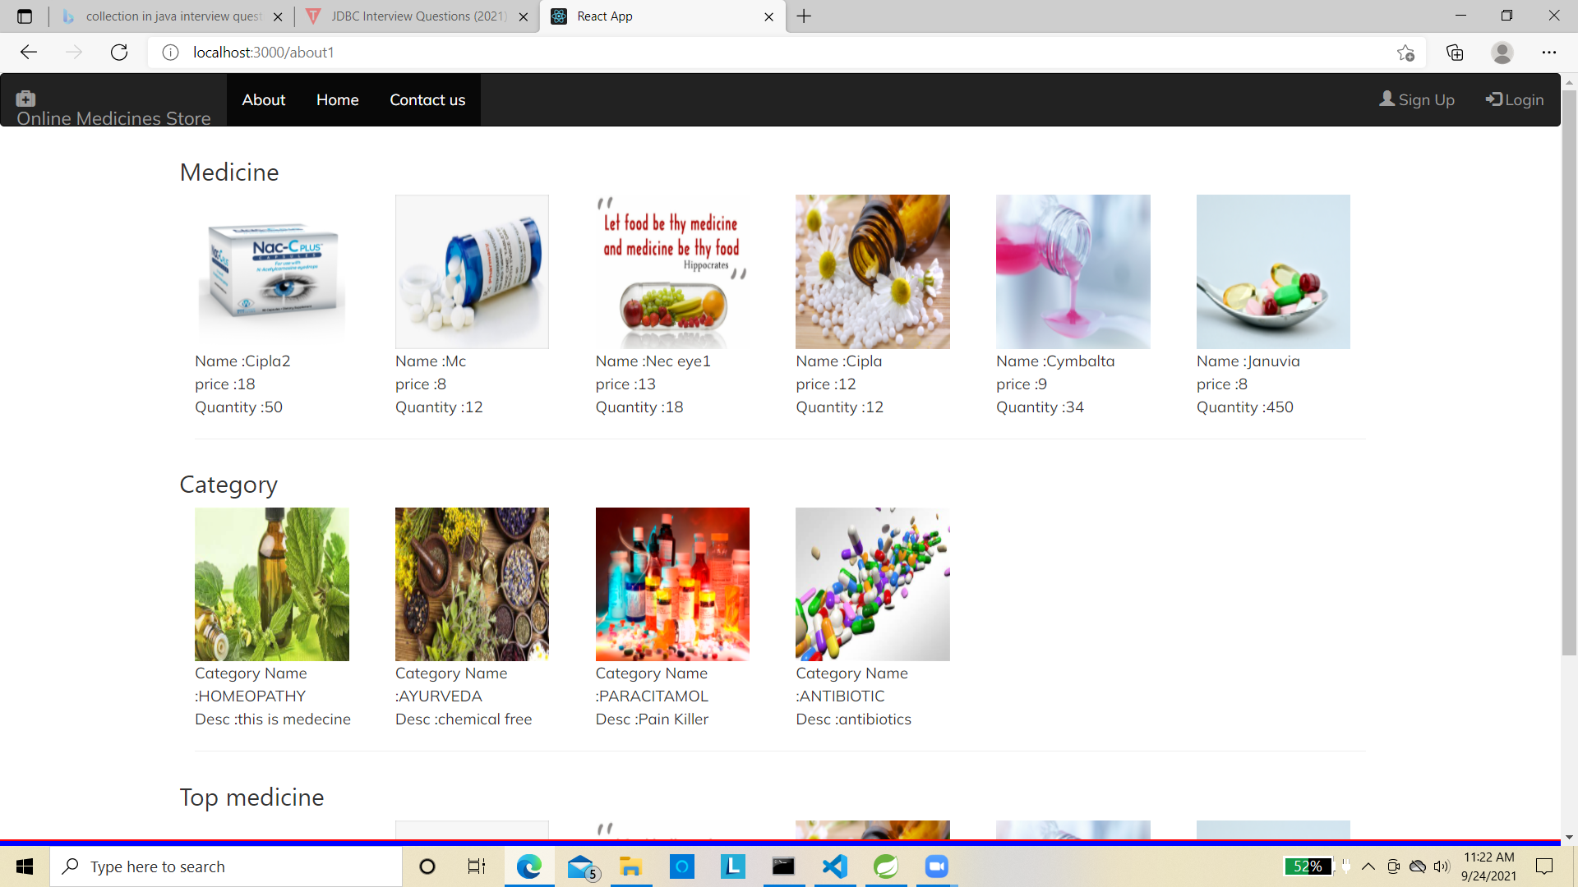

**Medicine Details**

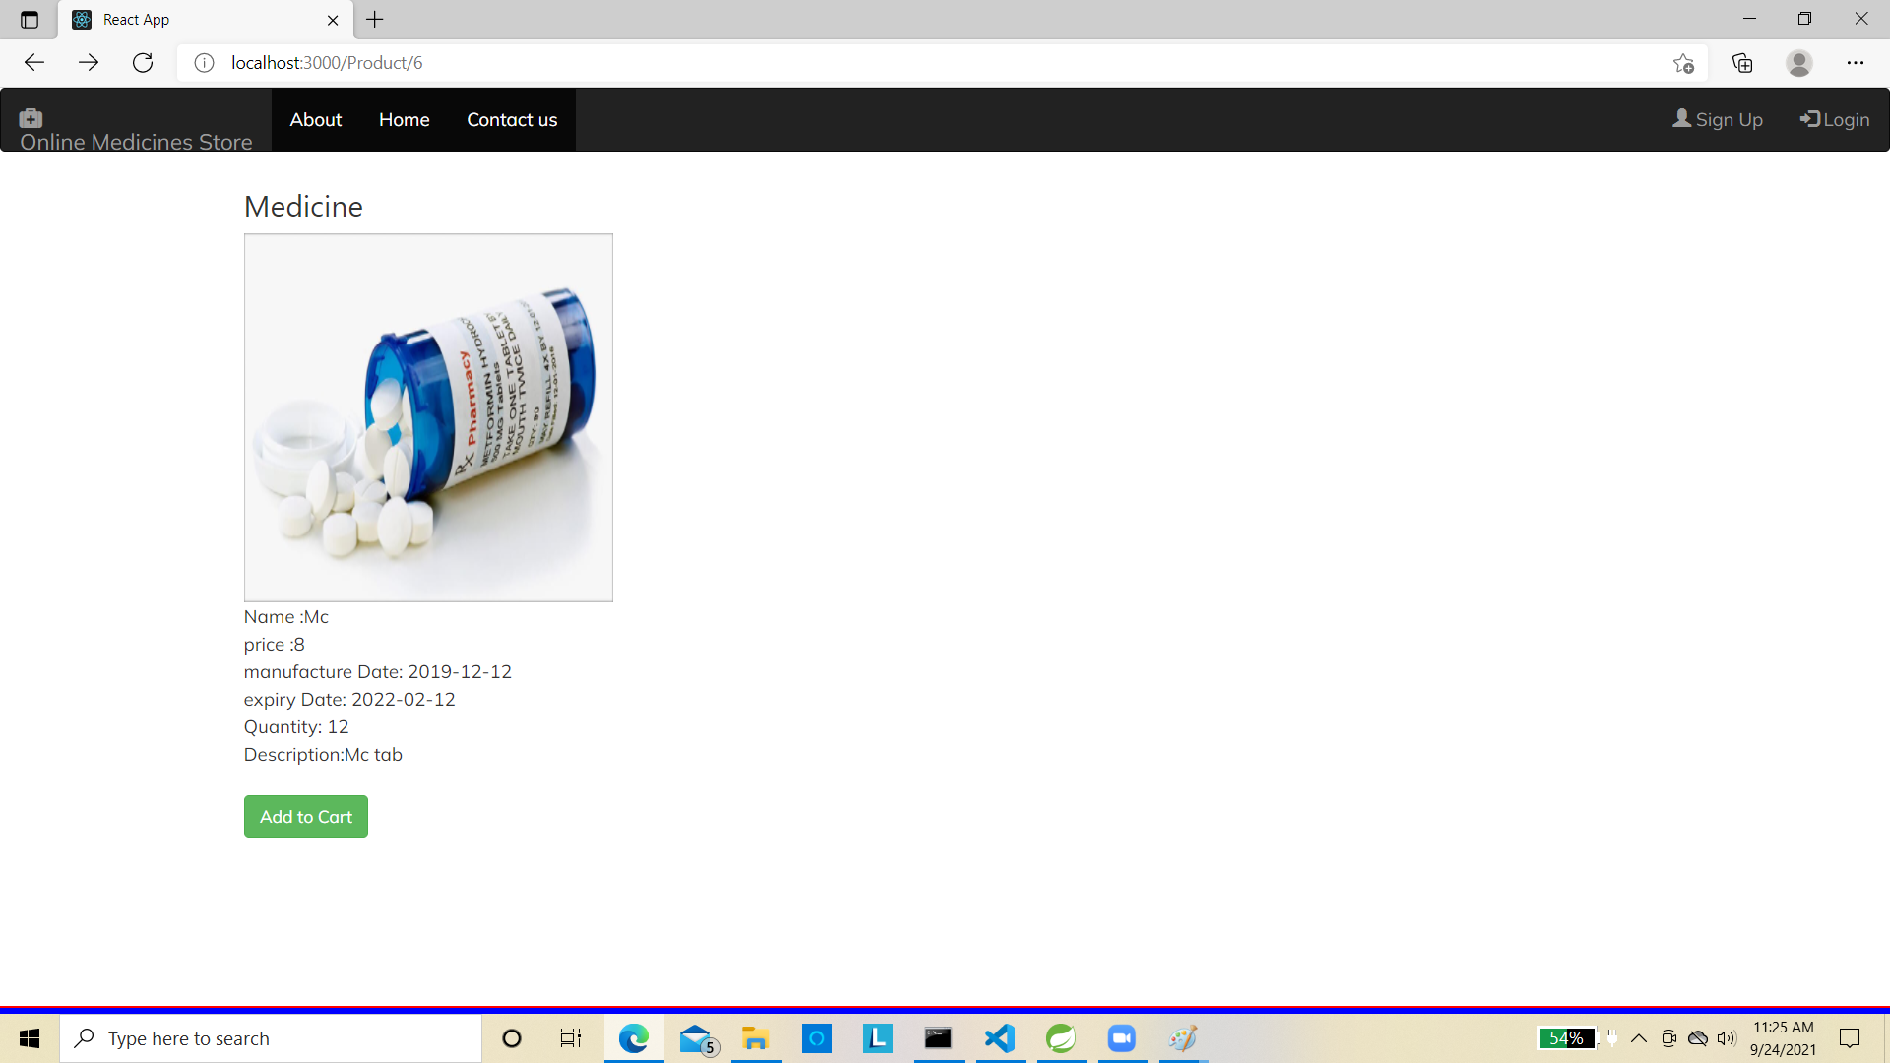

**About Us**

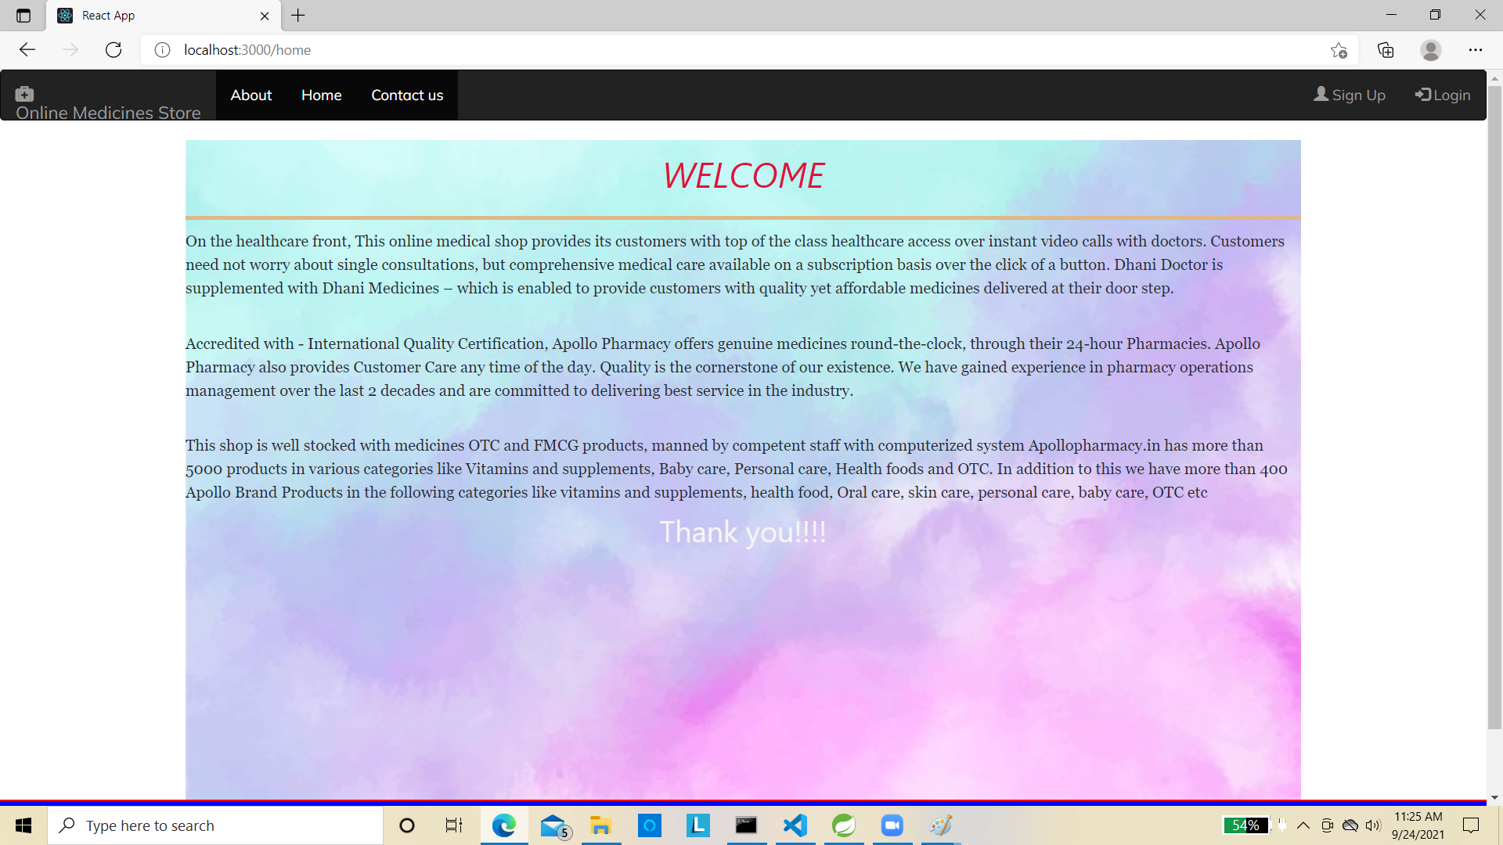

**Contact Us**

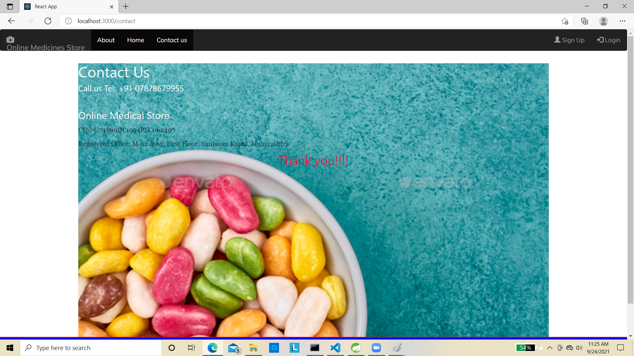

**Add TO Cart**

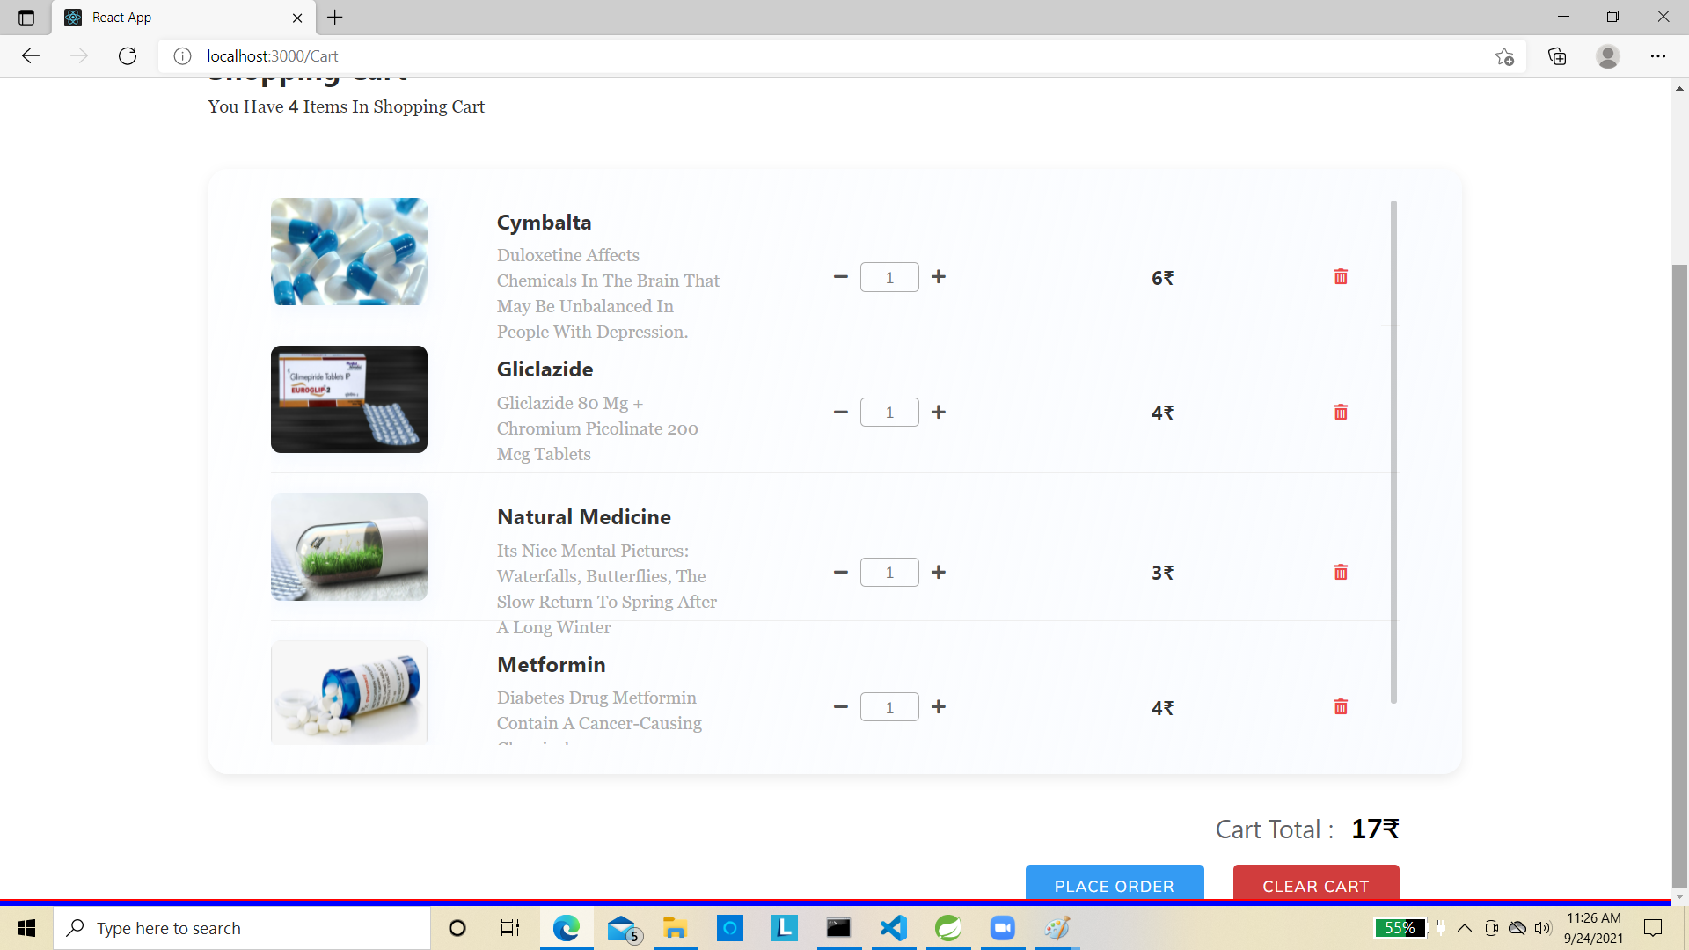

**Order Placed**

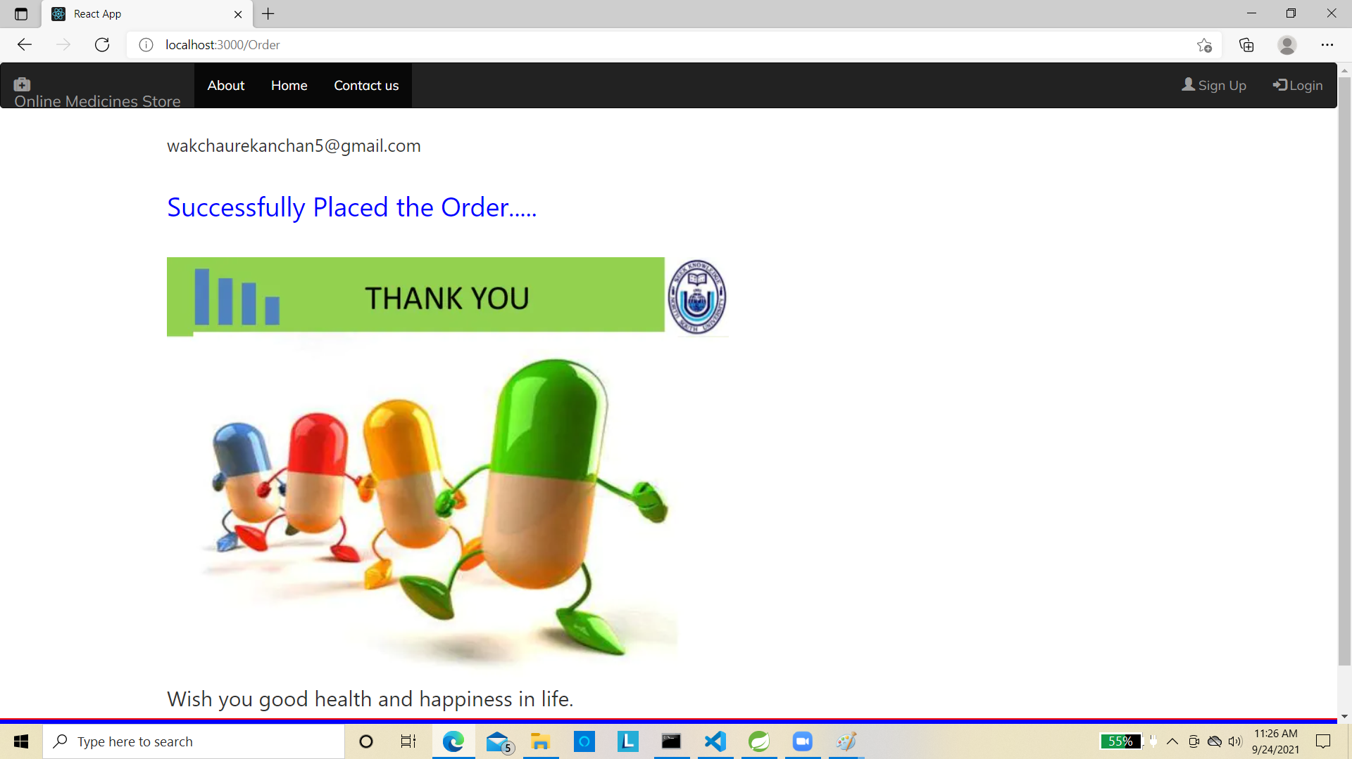

**Admin Side**

**Medicine List**

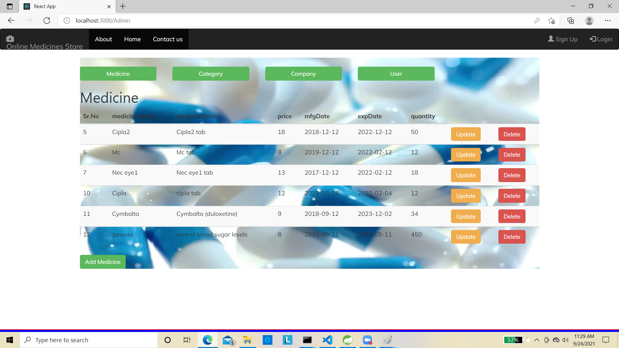

**Category List**

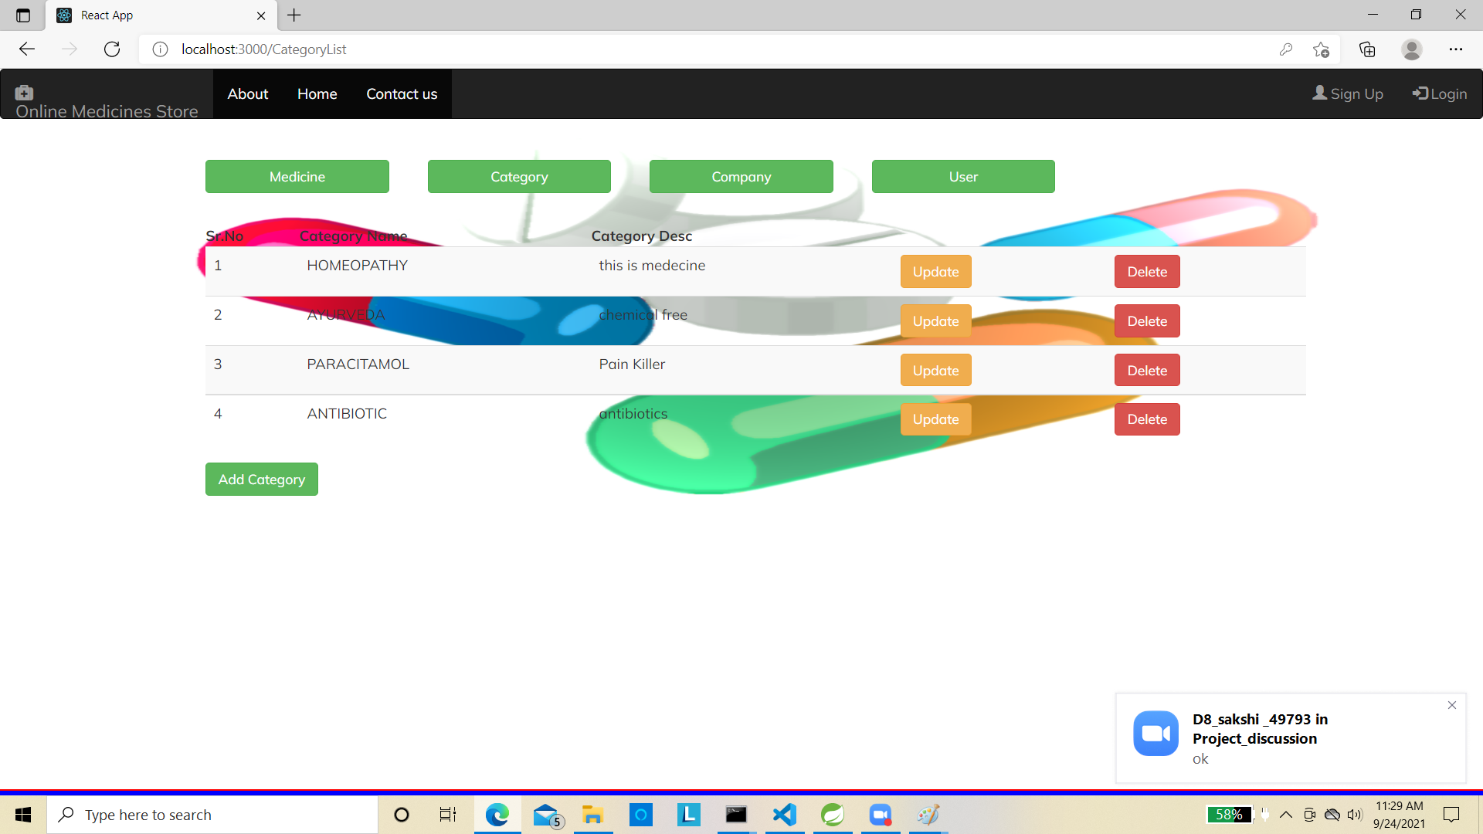

**Company List**

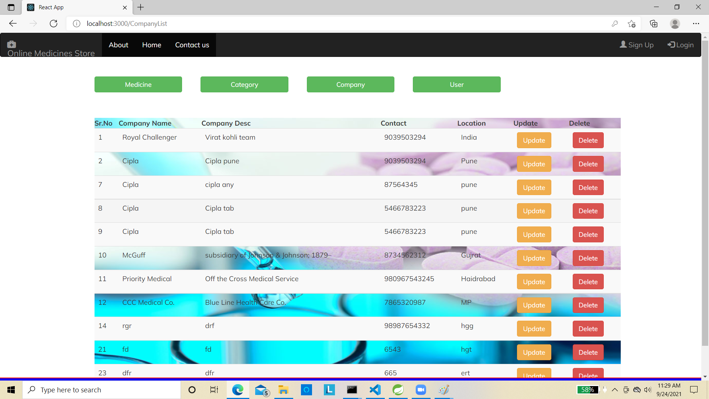

**User List**

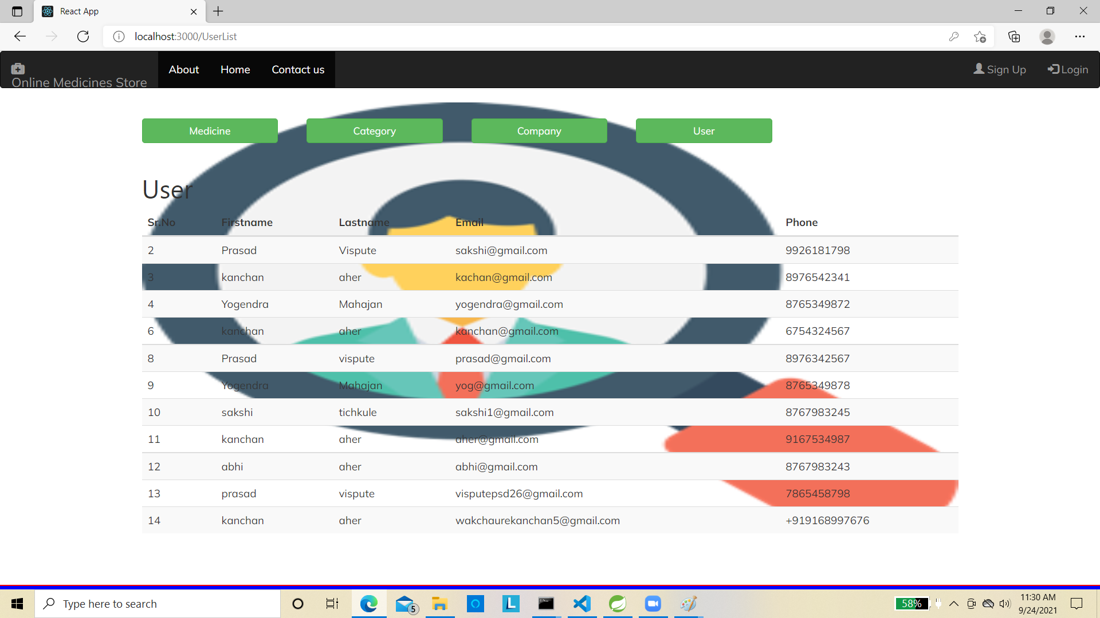

**Sign up Page**

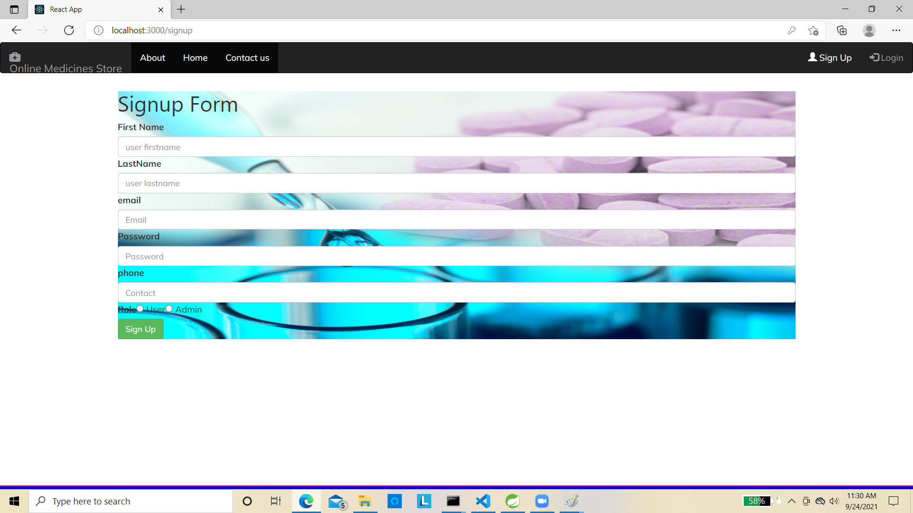

**Login Page**

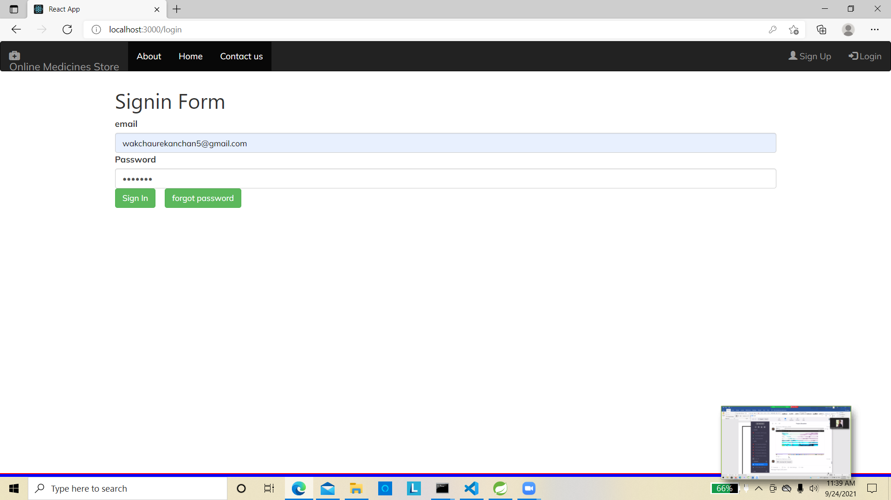

**7.REFERENCES:**

<https://pharmacy.dhani.com/>

<https://www.w3schools.com/>

<http://www.wikipedia.org>

<https://getbootstrap.com/>

<https://docs.spring.io/spring-data/jpa/docs/current/reference/html/#jpa.query-methods.query-creation>

<https://www.javadevjournal.com/spring/password-encoding-in-spring-security/>

<https://www.baeldung.com/hibernate-one-to-many>